1.Draw a simple network diagram showing three devices (like your phone, a friend's laptop, and a smart TV) connected through a router, and label the IP addresses for each device and the router's interfaces.
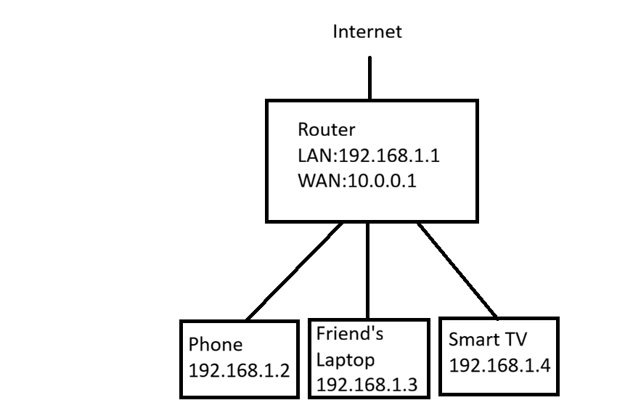
2.Simulate manual IP routing by writing a step-by-step explanation of how a packet would travel from your laptop to a friend's computer in a different subnet, including which router(s) it passes through and how the routing decision is made.<br><br><em><strong>Hint:</strong> Use made-up IP addresses and show the routing table entries that would be checked at each hop.</em>
->Manual IP Routing
Network Details
- My Laptop IP: 192.168.1.10/24
- Default Gateway (Router R1): 192.168.1.1
- Router R2 Interface: 10.0.0.2
- Friend's Network: 192.168.2.0/24
- Friend's Computer IP: 192.168.2.20
Step-by-Step Packet Travel
Step 1:
My laptop (192.168.1.10) wants to send data to my friend's computer (192.168.2.20).
Step 2:
The laptop checks whether 192.168.2.20 is in the same subnet.
My subnet = 192.168.1.0/24
Destination subnet = 192.168.2.0/24
Since both subnets are different, the laptop sends the packet to its default gateway (192.168.1.1)
Laptop Routing Table
Destination | Next Hop
192.168.1.0/24 | Directly Connected
192.168.2.0/24 | 10.0.0.2

Step 3:
Router R1 receives the packet and checks its routing table.
Router R1 Routing Table
Destination | Next Hop
192.168.1.0/24 | Directly Connected
192.168.2.0/24 | 10.0.0.2
R1 forwards the packet to Router R2.
Step 4:
Router R2 receives the packet and checks its routing table.
Router R2 Routing Table
Destination | Next Hop
192.168.2.0/24 | Directly Connected

Router R2 sends the packet directly to the friend's computer.
Packet Path
My Laptop (192.168.1.10)
│
Router R1 (192.168.1.1)
│
Router R2 (10.0.0.2)
│
Friend's PC (192.168.2.20)
Conclusion
The packet first reaches the default gateway (Router R1). Router R1 checks its routing table and forwards the packet to Router R2. Router R2 finds that the destination network is directly connected and delivers the packet to the friend's computer. This is how manual IP routing works between different subnets.
3.Create a routing table for a fictional Zomato-style delivery network with three branches in different cities, each on a different subnet. Specify the network address, subnet mask, next hop, and interface for each route.
Destination Network | Subnet Mask | Next Hop | Interface
192.168.10.0 | 255.255.255.0 | Directly Connected | GigabitEthernet0/0
192.168.20.0 | 255.255.255.0 | 10.0.0.2 | Serial0/0/0
192.168.30.0 | 255.255.255.0 | 10.0.0.3 | Serial0/0/1

4.Compare static routing and dynamic routing protocols (like RIP or OSPF) by listing 3 pros and 3 cons of each, using examples from real-world apps or services you use (e.g., how a food delivery app might benefit from dynamic routing).
Static Routing | Dynamic Routing (RIP/OSPF)
Pros: | Pros:
1. Easy to configure in small networks. | 1. Automatically updates routes when the network changes.
2. Uses less CPU and bandwidth. | 2. Best for large networks with many routers.
3. More secure because routes are manually configured. | 3. Finds the best available path automatically.
Cons: | Cons:
1. Not suitable for large networks. | 1. More complex to configure.
2. Every route must be updated manually. | 2. Uses more CPU, memory, and bandwidth.
3. If a link fails, traffic stops until the route is changed manually. | 3. Takes some time to learn and update routes.

5.Use ChatGPT or another AI tool to generate a sample configuration for setting up OSPF routing between two routers, then explain in your own words what each configuration line does.<br><br><em><strong>Hint:</strong> Paste the AI-generated config and annotate each part with a short description.</em>
AI-Generated OSPF Configuration
Router R1
enable
configure terminal
router ospf 1
network 192.168.1.0 0.0.0.255 area 0
network 10.0.0.0 0.0.0.3 area 0
end
Router R2
enable
configure terminal
router ospf 1
network 192.168.2.0 0.0.0.255 area 0
network 10.0.0.0 0.0.0.3 area 0
end
Command | Explanation
enable | Enters privileged EXEC mode.
configure terminal | Enters global configuration mode.
router ospf 1 | Starts the OSPF routing process with process ID 1.
network 192.168.1.0 0.0.0.255 area 0 | Enables OSPF for the 192.168.1.0/24 network in Area 0. (Router R1)
network 192.168.2.0 0.0.0.255 area 0 | Enables OSPF for the 192.168.2.0/24 network in Area 0. (Router R2)
network 10.0.0.0 0.0.0.3 area 0 | Enables OSPF on the serial link between the two routers.
end | Exits configuration mode.

